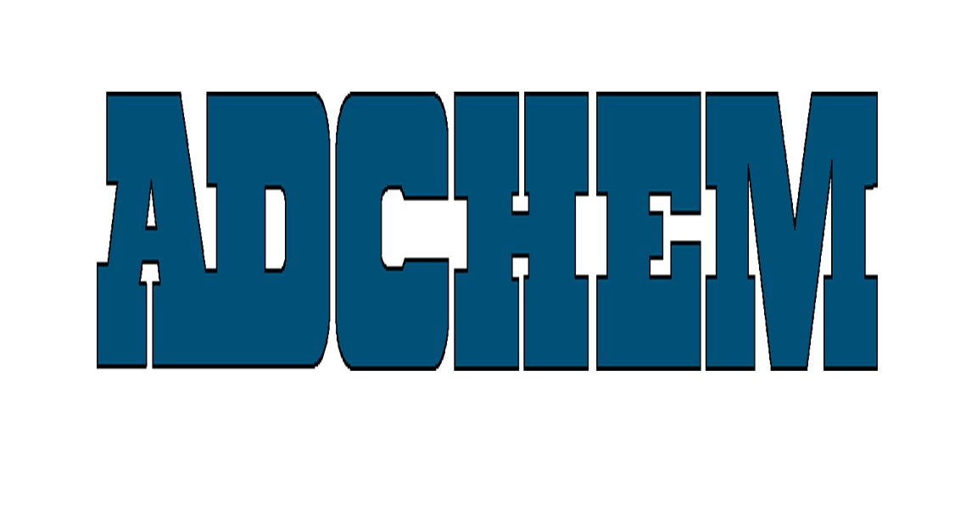
For Immediate Release:

Adchem Corporation Offers 7833 and 7834 High Performance Transfer Tapes

Adchem Corporation, a leading manufacturer of innovative, pressure-sensitive adhesive tape systems, offers high performance adhesive transfer tapes for bonding to foams used in the sound attenuation and vibration damping market. These high performance transfer tapes are part of Adchem’s broad range of bonding solutions used in automotive, electronics and general industrial applications. Adchem provides acrylic and rubber adhesive systems and acrylic/rubber hybrid products for OEMs and fabricators worldwide.

Adchem’s 7833-74 and 7834-74 durable transfer tapes consist of 3-mils and 4-mils respectively of a pressure sensitive acrylic adhesive system, ideal for elevated temperature performance to 300ºF. The 74# polycoated liner is engineered for easy release from such fragile foams as melamine. Adchem’s adhesive transfer tapes provide excellent adhesion to most foams, and plastic materials including low surface energy substrates.

The leader in the engineering of transfer tapes for more than 40 years, Adchem provides more than 50 unique adhesive solutions for customers’ most demanding bonding needs. This broad range of products reduces the need for large inventories of narrower spectrum systems. Adchem also offers competitive pricing and engineering support that are unmatched by both smaller and larger adhesive tape suppliers.

About Adchem Corporation

Adchem, an ISO 9001 certified and A2LA accredited company, manufactures an innovative line of pressure-sensitive adhesive tape systems, including double-coated papers, films, tissues, foams and fabrics; transfer tapes; one-side coated products and other custom-coated specialty products. Our 100% solids adhesives, solvent and water based acrylics and rubber adhesives are used in a variety of industries, including automotive, construction, electronics, graphic arts, medical and general industrial tape applications.
For additional information and samples, please contact Adchem Corporation, 1852 Old Country Road, Riverhead, NY 11901 Phone: (631) 727-6000 Fax: (631) 727-6010 or our website at www.adchem.com.

